SMART HELMET SYSTEM FOR RIDER SAFETY

ABSTRACT

The Smart Helmet System for Rider Safety is an IoT-based embedded solution that improves two-wheeler safety through prevention, monitoring, and emergency response. It uses sensors to ensure the rider is wearing the helmet properly; if not, the ignition system is disabled, enforcing safety compliance.
An MQ-3 alcohol sensor checks the rider’s breath for alcohol. If the detected level exceeds a set limit, the system prevents the vehicle from starting, reducing the risk of accidents due to drunk driving.
The system also includes accident detection using sensors like accelerometers or vibration sensors. In case of a sudden impact, it automatically sends an emergency alert to predefined contacts through a GSM module, along with the rider’s real-time location obtained via GPS.
A microcontroller such as ESP32 controls the entire system by processing sensor data and triggering appropriate actions. Overall, the system is compact, reliable, and helps enhance road safety by combining automation, real-time tracking, and intelligent decision-making.

TABLE OF CONTENTS

CHAPTER
NO.

TITLE

PAGE NO.

ABSTRACT ^{v}
LIST OF FIGURES vii
LIST OF TABLES viii

- INTRODUCTION TO DESIGN THINKING 1
1.1 Objective 1
1.2 Origin 2
1.3 Purpose and Innovation 2
1.4 Creativity and Collaboration 2

- PROCESS OF DESIGN THINKING 3
  - Empathize ³
  - Problem Statement 3
  - Ideation 4
  - Prototype 5
  - Testing 5
- EXISTING PRODUCT 5
  - Features 5
- SOFTWARE AND HARDWARE REQUIREMENTS 6
- STANDARD SPECIFICATIONS 7
- PROPOSED PRODUCT 8
6.1 Block Diagram 9
6.2 Architecture Diagram 10
6.3 Flow Diagram 11
6.4 Design/Circuit Diagram 12
- FEASIBILITY STUDY 12
- PROTOTYPE AND IMPLEMENTATION 13
- TESTING 14
- APPLICATIONS 15
- FUTURE ENCHANCEMENTS 16
- REFERENCES 17

vi


FIG 6.1 BLOCK DIAGRAM 10

FIG 6.2 ARCHITECTURE DIAGRAM 11

FIG 6.3 FLOW DIAGRAM 12

FIG 6.4 DESIGN DIAGRAM 13

LIST OF TABLES

TABLE NO | TABLE NAME | PAGE NO
4.1 | HARDWARE REQUIREMENTS | 7
4.2 | SOFTWARE REQUIREMENTS | 8
9.1 | TESTING  OBSERVATION | 16

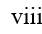

1.INTRODUCTION TO DESIGN THINKING
Design Thinking is a human-centered and iterative problem-solving approach used to develop innovative and practical solutions by focusing on user needs. It emphasizes understanding real-world problems, generating creative ideas, and testing solutions continuously. Unlike traditional methods that directly jump to solutions, Design Thinking begins with deep empathy for users and follows a structured process to ensure effective outcomes. It integrates technology feasibility, user desirability, and economic viability, making it widely applicable in engineering, business, and product development .
In the Smart Helmet System for Rider Safety, Design Thinking helps in identifying key issues such as helmet negligence, drunk driving, and delayed emergency response, and transforming them into an innovative safety solution.
- Human-Centered Approach
Design Thinking focuses on understanding the needs, behaviors, and challenges of users (riders). It ensures that solutions are designed based on real-life problems rather than assumptions, leading to more effective and practical outcomes.
- Iterative Process
The process follows stages like empathize, define, ideate, prototype, and test. These stages are not linear and can be repeated to improve the solution continuously based on feedback and testing.
- Problem-Solving Capability
It helps in solving complex and undefined problems by breaking them into smaller parts and approaching them creatively. This makes it highly suitable for real-world challenges like road safety.
- Integration of Technology and Innovation
Design Thinking combines user needs with modern technology such as IoT, sensors, and communication systems to develop smart solutions like the Smart Helmet system.

1.1 OBJECTIVE
- To develop a smart safety system that ensures helmet usage before vehicle ignition.
- To detect alcohol consumption using sensors and prevent unsafe driving conditions.
- To design an automated accident detection system that identifies crashes in real time.
- To provide instant emergency alerts with location details using GPS and GSM modules.
- To create a system that is user-friendly and requires minimal manual interaction.
- To reduce road accidents and fatalities caused by negligence and unsafe driving practices.
- To build a cost-effective and scalable solution that can be widely implemented.
- To promote awareness and responsible riding behavior among users.

1.2 ORIGIN
- Design Thinking originated from the field of design and was later popularized by organizations like IDEO and academic institutions such as Stanford University.
- It evolved as a human-centered innovation methodology that focuses on solving problems creatively by understanding user needs .
- The concept gained importance in engineering and technology fields due to its ability to handle complex and real-world problems effectively.
- The Smart Helmet project originated from the increasing road accident rates involving two-wheeler riders, especially due to lack of helmet usage and drunk driving.
- Traditional helmets provide only passive safety, which led to the idea of integrating technology for active safety enforcement.
- The availability of IoT, embedded systems, sensors, GPS, and GSM technologies made it possible to develop an intelligent safety solution.
- The project is inspired by the need to provide real-time monitoring and emergency response systems.
- Thus, the origin lies in combining Design Thinking principles with modern technology to address critical safety issues.

1.3 PURPOSE AND INNOVATION
- It aims to prevent accidents by ensuring safe riding conditions before vehicle operation.
- The system provides real-time monitoring and emergency assistance, improving survival chances during accidents.
- It promotes discipline and awareness among riders by enforcing safety rules.
- Innovation lies in integrating multiple technologies such as helmet detection sensors, alcohol sensors, GPS, and GSM modules into a single system.
- The project introduces automation, where the system operates without manual intervention.
- It transforms a traditional helmet into an intelligent safety device.
- The system combines hardware and software integration for efficient functioning.
- It opens possibilities for future enhancements like mobile applications, cloud connectivity, and smart city integration.
- Overall, it represents a modern and innovative approach to road safety solutions.

1.4 CREATIVITY AND COLLABORATION
- Creativity plays a key role in generating innovative ideas and unique solutions for real-world problems.
- It helps in designing a system that integrates safety, automation, and user convenience.
- Creative thinking enables the development of features like automatic ignition control and accident alert systems.
- It encourages exploring multiple solutions and selecting the most effective one.
- Collaboration involves teamwork and sharing of ideas among group members.
- It helps in combining knowledge from different areas such as hardware design, programming, and testing.
- Team members contribute to various stages like design, development, and implementation.
- Collaboration improves problem-solving efficiency and system accuracy.
- Interaction with mentors and feedback from users enhances the quality of the system.
- It ensures that the final product is practical, reliable, and user-friendly.
- The combination of creativity and collaboration leads to the successful development of an innovative Smart Helmet System that meets real-world requirements.

2.PROCESS OF DESIGN THINKING
- The Design Thinking process is a structured, iterative methodology used to solve complex problems by focusing on user needs and innovative solutions. It consists of multiple stages that help in understanding the problem deeply, generating ideas, and developing effective solutions. In the Smart Helmet System for Rider Safety, this process plays a crucial role in transforming real-world safety issues into a practical and intelligent system.
- The process begins with understanding the users (riders), identifying their problems, and analyzing the challenges they face in daily life. It then moves to defining clear problem statements, followed by generating multiple creative ideas to address these issues. These ideas are then converted into prototypes, which are tested and improved based on feedback.
- Design Thinking is not a linear process; it is cyclical and flexible, allowing continuous refinement of solutions. This ensures that the final product is not only technically feasible but also user-friendly and effective. In this project, the process helps in developing a system that ensures helmet usage, detects alcohol consumption, and provides emergency alerts, thereby improving overall road safety.

2.1 EMPATHIZE
- Empathize is the first stage of Design Thinking, focusing on understanding the users and their needs.
- It involves studying the behavior, challenges, and expectations of two-wheeler riders.
- Many riders neglect wearing helmets due to discomfort, carelessness, or lack of awareness.
- Drunk driving is identified as a major cause of accidents due to reduced alertness and poor judgment.
- Riders often face situations where immediate help is not available during accidents.
- Families expect a system that can provide quick alerts in emergency situations.
- Existing safety measures are mostly manual and not strictly enforced.
- Users prefer solutions that are simple, affordable, and automatic.
- Increasing traffic and rash driving further highlight the need for advanced safety systems.
- This stage helps in gaining insights that guide the development of a user-centered Smart Helmet system.

2.2 PROBLEM STATEMENT
- The problem statement clearly defines the core issue that needs to be solved.
- Two-wheeler accidents are increasing due to lack of helmet usage and drunk driving.
- Riders often ignore safety measures, leading to severe injuries and fatalities.
- Alcohol consumption significantly reduces reaction time and decision-making ability.
- Traditional helmets provide only basic protection without any smart features.
- Emergency response is often delayed due to lack of real-time accident detection and communication.
- Existing systems do not provide automated monitoring or preventive safety measures.
- There is a need for a system that can enforce safety rules and provide instant assistance.
- Therefore, the problem is to design a smart, automated helmet system that ensures safety, prevents accidents, and provides emergency support.

2.3 IDEATION
- Ideation involves generating creative and innovative solutions to solve the defined problem.
- Multiple ideas are brainstormed to address safety issues in an effective way.
- A helmet detection system is proposed using IR or pressure sensors to ensure proper usage.
- An alcohol detection system using MQ-3 sensor is introduced to identify intoxication levels.
- An ignition control mechanism is designed to prevent vehicle start in unsafe conditions.
- A GPS module is included to track the real-time location of the rider.
- A GSM module is used to send emergency alerts to predefined contacts.
- A buzzer or LED alert system is added to notify unsafe conditions.
- The idea of integrating all components into a single embedded system is developed.
- The focus is on creating a solution that is automated, reliable, and easy to use.
- Ideation helps in selecting the most feasible and effective solution for implementation.

2.4 PROTOTYPE
- Prototyping involves creating a working model of the proposed solution.
- The Smart Helmet prototype is developed by integrating hardware and software components.
- Components such as ESP32 microcontroller, sensors, GPS, and GSM modules are assembled.
- Sensors are connected to collect real-time data from the rider and environment.
- The system is programmed using Arduino IDE and Embedded C.
- The prototype is designed to be compact and fit inside the helmet structure.
- It demonstrates the working of features like helmet detection, alcohol sensing, and alert system.
- Prototyping helps in identifying design issues and technical challenges.
- It allows testing of system functionality before final implementation.
- The developed prototype represents a practical model of the Smart Helmet system.

2.5 TESTING
- Testing is the final stage of Design Thinking, used to evaluate the performance and reliability of the system.
- The Smart Helmet is tested under different real-time conditions.
- Helmet detection is tested to ensure the system works only when the helmet is worn.
- Alcohol sensor is tested to verify accurate detection of intoxication levels.
- GPS module is tested for location accuracy and tracking performance.
- GSM module is tested to ensure timely delivery of emergency alerts.
- Accident detection mechanism is tested using simulated conditions.
- System response time and efficiency are evaluated.
- Testing helps in identifying errors and areas for improvement.
- Feedback from users is collected to enhance usability and performance.
- The system is refined to ensure it is reliable, efficient, and ready for real-world use.
3. EXISTING PRODUCT
- The existing product in this domain mainly refers to traditional helmets used by two-wheeler riders.
- These helmets are designed primarily for head protection during accidents and are mandatory in many countries.
- Traditional helmets are made using hard outer shells and inner cushioning materials to absorb impact forces.
- They function as passive safety equipment, meaning they only provide protection after an accident occurs.
- There is no intelligence or automation involved in conventional helmet systems.
- Existing helmets do not have the capability to monitor rider behavior or riding conditions.
- They lack features to prevent accidents before they happen.
- There is no mechanism to ensure whether the rider is wearing the helmet properly.
- Traditional helmets do not include alcohol detection or safety enforcement systems.
- They also do not provide real-time communication or emergency alert mechanisms.
- In case of accidents, assistance depends on external factors such as bystanders or emergency services, leading to delays.
- Due to these limitations, traditional helmets are considered insufficient in modern safety requirements.
- This highlights the need for an advanced smart helmet system with integrated technologies.

3.1 FEATURES
- Provides basic head protection against injuries during accidents.
- Made with impact-resistant outer shell and shock-absorbing inner lining.
- Includes chin strap mechanism to secure the helmet on the rider’s head.
- Designed for comfort and ventilation to allow airflow.
- Available in different sizes, shapes, and designs for user convenience.
- Lightweight construction for ease of use and reduced fatigue.
- Complies with basic safety standards and regulations.
- Does not include any electronic or smart features.
- No system to detect helmet usage automatically.
- No capability to monitor rider condition or behavior.
- Lacks accident detection and emergency response system.
- No integration with GPS or communication technologies.
- Functions only as a protective gear, not as a preventive safety system.

4 SOFTWARE AND HARDWARE REQUIREMENTS
- The Smart Helmet system requires both hardware components and software tools for proper functioning.
Hardware Requirements
- ESP32 Microcontroller
  - Acts as the central processing unit of the system.
  - Processes data from sensors and controls system operations.
- MQ-3 Alcohol Sensor
  - Detects alcohol presence in the rider’s breath.
  - Helps in preventing drunk driving.
- GPS Module (NEO-6M)
  - Provides real-time location tracking.
  - Used in emergency alert system.
- GSM Module (SIM800L)
  - Sends SMS alerts to predefined contacts.
  - Enables communication during emergencies.
- SOS Button
  - Allows manual triggering of emergency alerts.
- Battery (7V 3000mAh)
  - Supplies power to the entire system.
- Breadboard / PCB
  - Used for circuit connections and component mounting.
- Jumper Wires and Resistors
  - Used for electrical connections and circuit stability.
- Buck Converter
  - Regulates voltage supply to different components.
- Helmet (Base Structure)
  - Acts as the physical platform to integrate all components.
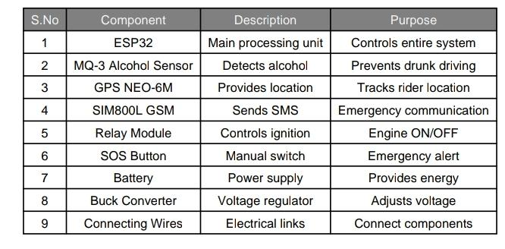
TABLE 4.1. HARDWARE REQUIREMENTS

Software Requirements
- Arduino IDE
  - Used for programming the ESP32 microcontroller.
- Embedded C Programming Language
  - Used to write code for system logic and control.
- ESP32 Development Environment
  - Required for uploading and executing code.
- GPS Libraries
  - Used to extract and process location data.
- GSM Libraries
  - Used for sending SMS and communication functions.
- Serial Monitor
  - Used for debugging and testing system output.
- Firmware Development
  - Handles real-time sensor data processing and decision-making.
- Software Integration
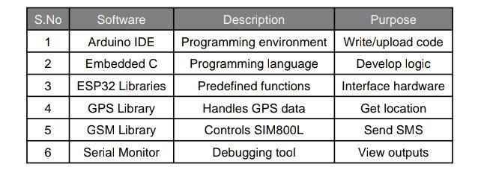
  - Ensures smooth communication between hardware components.
TABLE 4.2. SOFTWARE REQUIREMENTS

5. STANDARD SPECIFICATIONS
- The Smart Helmet system is designed in accordance with safety and quality standards to ensure reliability and effectiveness.
- It follows guidelines similar to the Bureau of Indian Standards (BIS) for helmet safety.
- Complies with IS 4151:2015 standard for protective helmets.
- Provides adequate impact resistance to protect the rider’s head.
- Ensures proper shock absorption capability during collisions.
- Includes a secure retention system (chin strap) for stability.
- Designed with durable outer shell materials for long-term use.
- Maintains lightweight structure for user comfort.
- Provides proper ventilation system to reduce discomfort.
- Capable of withstanding environmental conditions such as heat, dust, and moisture.
- Ensures electrical safety for embedded electronic components.
- Uses low-power consumption components for efficiency.
- Designed to be ergonomic and user-friendly.
- Ensures safe integration of sensors and electronic modules within the helmet.
- Supports reliable communication systems (GPS & GSM).
- Meets requirements for real-world implementation and scalability.

6.PROPOSED PRODUCT
The proposed product is a Smart Helmet System for Rider Safety, designed to overcome the limitations of traditional helmets by integrating advanced technologies such as sensors, microcontrollers, GPS, and GSM communication modules. This system acts as an intelligent safety device that not only protects the rider physically but also ensures safe riding practices and provides real-time monitoring.
The Smart Helmet ensures that the rider wears the helmet properly before starting the vehicle by using a helmet detection mechanism. It also includes an alcohol detection system that prevents the engine from starting if the rider is intoxicated. In addition, the system incorporates an accident detection feature that identifies sudden impacts or abnormal conditions and automatically sends emergency alerts along with the rider’s location to predefined contacts.
The entire system is controlled by a microcontroller (ESP32), which processes inputs from various sensors and controls outputs such as ignition control, alert systems, and communication modules. The integration of GPS and GSM technologies enables real-time tracking and communication, making the system highly efficient in emergency situations.
Overall, the proposed Smart Helmet system provides a preventive, automated, and reliable solution for improving road safety. It promotes responsible riding behavior, reduces accident risks, and ensures timely assistance during emergencies.

6.1 BLOCK DIAGRAM
- The block diagram represents the overall structure of the Smart Helmet system.
- It shows the relationship between input, processing, and output components.
- Input Components:
- MQ-3 alcohol sensor to detect alcohol levels.
- Relay module sensor to detect crashes.
- Processing Unit:
- ESP32 microcontroller acts as the central controller.
- Processes sensor data and makes decisions based on programmed logic.
- Output Components:
- Ignition control system to allow or prevent vehicle start.
- Buzzer/LED for alert notifications.
- Communication Modules:
- GPS module for real-time location tracking.
- GSM module for sending emergency alerts.
- Power Supply:
- Battery and voltage regulator provide power to all components.
- The block diagram clearly shows the flow of data from sensors to controller and then to output devices.
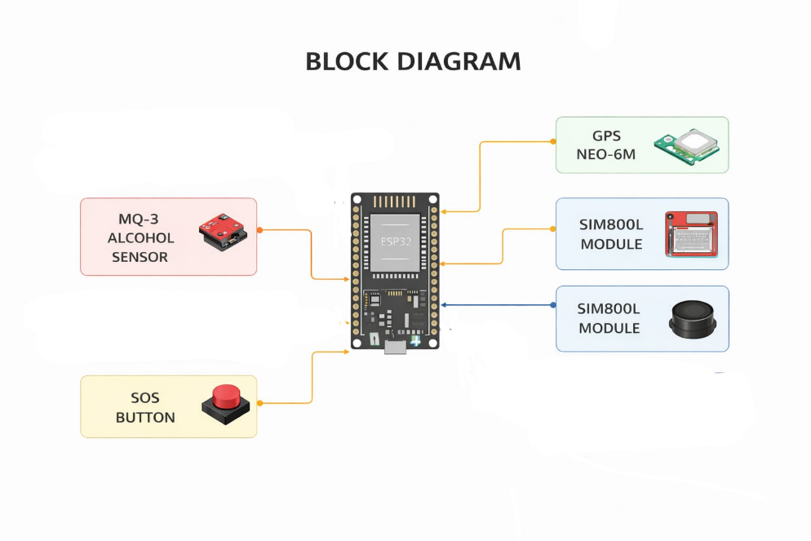

FIG 6.1 BLOCK DIAGRAM

6.2 ARCHITECTURE DIAGRAM
- The architecture diagram explains the internal structure and working layers of the system.
- It shows how different modules are interconnected and function together.
- Sensing Layer:
- Includes IR sensor, alcohol sensor, and vibration sensor.
- Collects real-time data from the rider and environment.
- Processing Layer:
- Consists of ESP32 microcontroller.
- Analyzes sensor inputs and executes decision-making algorithms.
- Communication Layer:
- GPS module provides location data.
- GSM module sends alerts to emergency contacts.
- Control Layer:
- Controls ignition system and alert mechanisms.
- Activates buzzer or sends notifications during unsafe conditions.
- User Interface Layer:
- Includes SOS button and alert indicators.
- Allows user interaction and manual emergency triggering.
- The architecture ensures efficient data flow, real-time processing, and reliable communication.

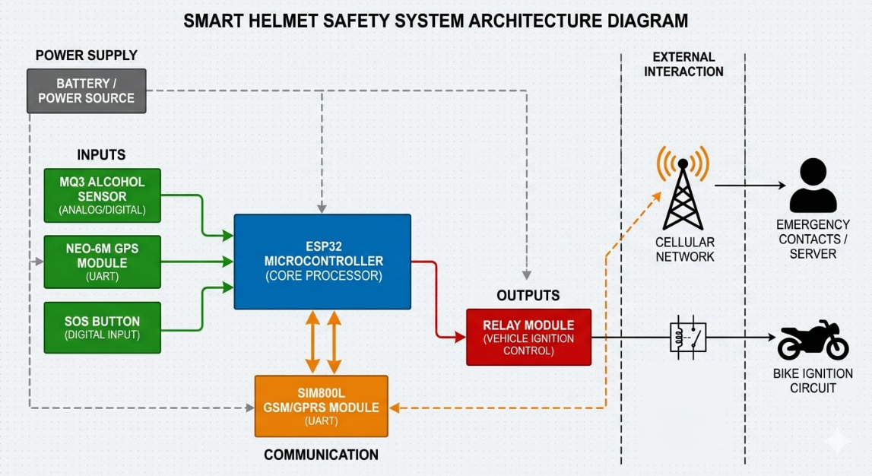
FIG 6.2. Architecture Diagram

6.3 FLOW DIAGRAM
- The flow diagram represents the step-by-step working process of the Smart Helmet system. .
- If the helmet is worn, the system proceeds to alcohol detection.
- Alcohol sensor checks for intoxication level in breath.
- If alcohol is detected above the threshold, the system blocks ignition.
- If no alcohol is detected, the system allows engine start.
- During riding, the system continuously monitors for accident conditions.
- If an accident is detected, the system activates emergency alert mechanism.
- GPS module retrieves current location coordinates.
- GSM module sends alert message with location details to predefined contacts.
- The system continues monitoring until it is manually turned OFF.

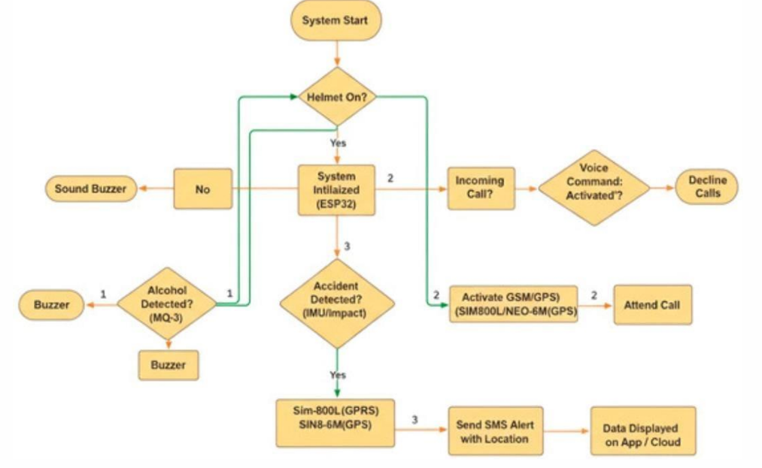

FIG 6.3. FLOW DIAGRAM

6.4 DESIGN / CIRCUIT DIAGRAM
- The design/circuit diagram shows the electrical connections between all components.
- ESP32 Microcontroller Connections:
- Connected to all sensors and modules as the main controller.
- Receives input signals and sends output commands.
- Sensor Connections:
- MQ-3 alcohol sensor connected for breath analysis.
- Vibration sensor connected for accident detection.
- Communication Module Connections:
- GPS module connected via serial communication for location data.
- GSM module connected for sending SMS alerts.
- Output Devices:
- Buzzer connected for alert indication.
- Ignition control relay connected to enable/disable engine start.
- Power Supply Section:
- Battery provides power to the system.
- Buck converter regulates voltage for safe operation.
- Circuit Design Features:
- Ensures stable and reliable connections.
- Designed for low power consumption.
- Compact layout suitable for helmet integration.
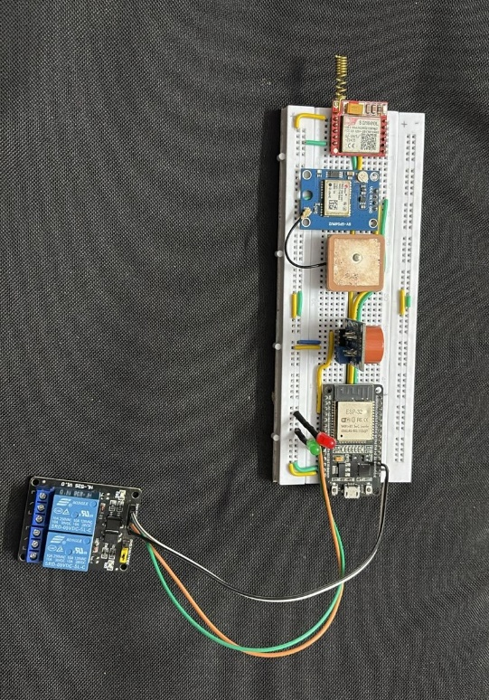
- The circuit diagram helps in understanding the practical implementation and hardware integration of the system.

FIG 6.4. DESIGN DIAGRAM

7.FEASIBILITY STUDY
Feasibility study is the process of analyzing whether the proposed Smart Helmet system can be successfully developed and implemented in real-world conditions. It evaluates different aspects such as technical, economic, operational, and legal feasibility.

Technical Feasibility
The Smart Helmet system is technically feasible because it uses commonly available components such as sensors, microcontrollers, GPS, and GSM modules. The integration of these components is simple and based on existing embedded system technology. The system requires basic programming using Arduino IDE and can be easily developed by students and engineers.

Economic Feasibility
The system is cost-effective as it uses low-cost hardware components like ESP32, MQ-3 sensor, and GPS module. There is no need for expensive equipment or complex infrastructure. The maintenance cost is also low, making it suitable for large-scale production and use by common riders.

Operational Feasibility
The Smart Helmet is easy to use and does not require technical knowledge from the user. It works automatically without manual intervention. The rider only needs to wear the helmet, and the system performs all safety checks. This makes it highly user-friendly and practical.

Legal Feasibility
The system supports road safety rules and regulations. It promotes helmet usage and prevents drunk driving, which are legally enforced in many countries. The system does not misuse personal data and aligns with safety standards.

Market Feasibility
There is a high demand for safety solutions due to increasing road accidents. The Smart Helmet has strong market potential as it provides advanced features compared to traditional helmets. It can be widely adopted by two-wheeler riders.

8.PROTOTYPE AND IMPLEMENTATION
The prototype is the working model of the Smart Helmet system, developed to demonstrate its functionality and performance in real-time conditions.

Prototype Development
The prototype is created by assembling all hardware components such as ESP32 microcontroller, sensors, GPS module, and GSM module inside the helmet. The components are arranged in a compact manner to ensure proper fitting and usability.

Hardware Integration
All sensors are connected to the microcontroller to collect real-time data. The GPS module is used for location tracking, and the GSM module is used for sending alert messages. The power supply is provided through a battery.

Software Implementation
The system is programmed using Arduino IDE and Embedded C. The code is written to process sensor inputs and control system outputs. The microcontroller continuously monitors conditions such as helmet usage, alcohol detection, and accident occurrence.

System Working
When the system is powered ON, it first checks whether the helmet is worn. Then it checks for alcohol presence. If both conditions are safe, the vehicle is allowed to start. During riding, the system monitors for accidents and sends alerts if needed.

Prototype Outcome
The developed prototype successfully demonstrates all features such as safety enforcement, real-time monitoring, and emergency alert system. It proves that the system can be implemented in real-world applications.

9.TESTING
Testing is carried out to evaluate the performance, accuracy, and reliability of the Smart Helmet system under different conditions.

Sensor Testing
The helmet detection sensor is tested to ensure it correctly identifies whether the helmet is worn. The alcohol sensor is tested to verify its ability to detect alcohol levels accurately.

GPS Testing
The GPS module is tested to check the accuracy of location tracking. It ensures that correct coordinates are obtained during emergency situations.

GSM Testing
The GSM module is tested to confirm that alert messages are sent successfully to predefined contacts. The timing and reliability of message delivery are also verified.

Accident Detection Testing
The system is tested under simulated accident conditions to ensure that it can detect sudden impacts and trigger alerts correctly.

Performance Testing
The overall system is tested for response time, efficiency, and continuous operation. It ensures that all components work together without failure.

Result of Testing
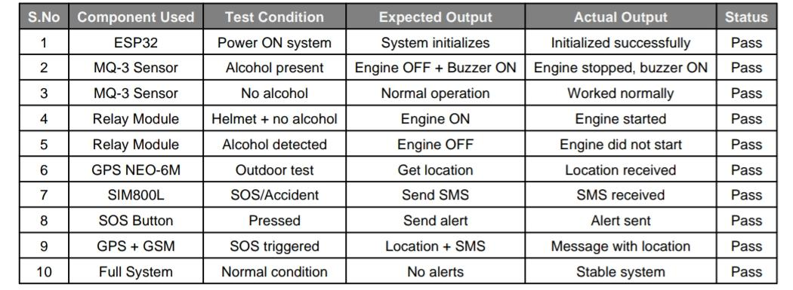
The testing results show that the system works reliably and responds quickly to different situations. It confirms that the Smart Helmet is suitable for real-world use.
TABLE 9.1. TESTING OBSERVATION

10.APPLICATIONS
The Smart Helmet system has various real-world applications in improving safety and monitoring.

Road Safety
The system helps in reducing accidents by ensuring helmet usage and preventing drunk driving. It improves overall road safety for two-wheeler riders.

Accident Detection and Emergency Response
It automatically detects accidents and sends alerts with location details, enabling quick medical assistance and saving lives.

Traffic Law Enforcement
The system supports traffic rules by enforcing helmet usage and preventing unsafe driving behavior.

Delivery and Transport Services
It can be used by delivery riders and transport workers to ensure their safety during long working hours.

Smart City Integration
The system can be integrated with smart city infrastructure for better traffic monitoring and emergency management.

11.FUTURE ENHANCEMENTS
Future enhancements can improve the performance and capabilities of the Smart Helmet system.

Mobile Application Integration
A mobile app can be developed to monitor helmet status, location, and alerts in real time.

Cloud Connectivity
Data can be stored in cloud servers for analysis, tracking, and future reference.

Advanced Sensors
Additional sensors such as heart rate sensors or fatigue detection sensors can be added monitor rider health.

Camera Integration
A camera can be added for recording ride data and providing evidence in case of accidents.

Voice Assistance
Voice alerts and commands can be integrated for better user interaction and convenience.

Improved Design
The size and weight of the system can be reduced to improve comfort and usability.

AI-Based Features
Artificial Intelligence can be used for advanced accident prediction and behavior analysis.
12. REFERENCES
The development of this project is based on fundamental concepts, practical knowledge, and learning resources.

1. Textbooks and Academic Sources

- Embedded Systems and Microcontroller textbooks
- Basic Electronics and Circuit Design books
- Sensor technology and applications

2. Online Educational Platforms

- Tutorials and courses related to Arduino and embedded systems
- Learning platforms explaining IR sensor working principles.

3. Arduino Documentation

- Official Arduino website and programming guides
- Code examples and hardware interfacing tutorials

- Official Arduino website and programming guides
- Code examples and hardware interfacing tutorials

4. Research Papers and Journals

- Studies on assistive devices for visually impaired people
- Papers related to wearable technology and smart devices

Project Guides and Mentors

- Guidance provided by faculty or project mentors
- Lab manuals and institutional resources

